“A community
of ordinary people
celebrating
an extraordinary God;
growing in faith,
serving in love,
proclaiming God’s grace.”

Welcome to Grace Lutheran Church
5/29/22

200 Wabash Avenue
Ukiah, CA 95482
Office (707) 462-7795

Pastor Kristi Gallimore
gracelutheranukiah@gmail.com www.gracelutheranukiah.com

Information for your first time at Grace…

THANK YOU for worshipping with us this day. We hope you experience the presence of God in this place and you are encouraged to further your personal relationship with Jesus Christ. If you’re looking for a community of believers to worship God with, we would like you to consider us your new church home. WELCOME!!

HOLY COMMUNION: is offered to all that hunger for the presence and promises of the risen Christ. We welcome all to the Lord’s Table at our service. Please ask the usher for a communion kit if you do not already have one.

RESTROOMS: are conveniently located in the fellowship hall and in the sanctuary hall.

OUR WORSHIP TODAY

MINISTERS: All Members of the Congregation

WORSHIP LEADER: Pastor Kristi Gallimore

MUSICIAN: Lori Schafer and Galen Gallimore

AUDIO VISUAL: Jack Vinyard, Andrew Gallimore, Cheryl Johnson

ASISSTANT/PRAYER:

READER: Pat Dabbs

USHER: Bill Yoder & Tyler Mello

CUSTODIAN: Prestino’s

Gathering

L=Leader A=Assistant R=Reader C=Congregation

Welcome To Grace Lutheran Chruch

CONFESSION AND FORGIVENESS (Please Stand)

P: Let us confess our sin in the presence of God and of one another.
[Silence is kept for reflection.]

P: Holy One,
C: we confess that we have wandered far from you:
we have not trusted your promises,
we have ignored your prophets in our own day,
we have squandered our inheritance of grace,
we have failed to recognize you in our midst.
Have mercy on us!
Forgive us and turn us again to you.
Teach us to follow in your ways,
assure us again of your love,
and help us to love our neighbor. C: Amen.

P: Beloved in Christ,
the Word draws near to you,
and all who call out to God shall be saved.
In Jesus, God comes to you again and again
and gathers you under wings of love.
In ☩ Jesus’ name, your sins are forgiven.
God journeys with you and teaches you how to live in love.
C: Amen.
Sharing the Peace Of GOD
[Please greet one another with a sign of Christ's peace with a hand gestor or wave.]

P: The grace of our Lord Jesus Christ, the love of God,
and the communion of the Holy Spirit be with you all.
C: And also with you.
P: The peace of the Lord be with you always.
C: And also with you.

Gather Us In ELW #532

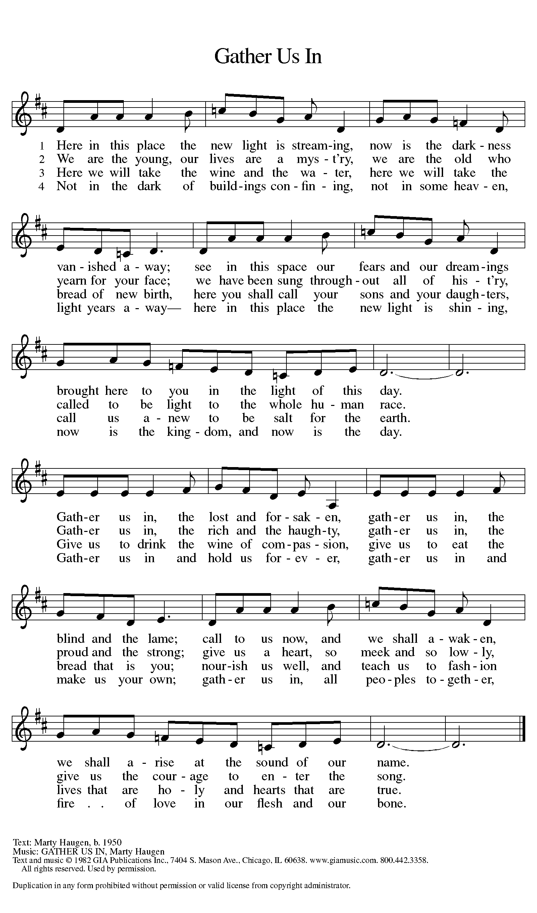

PRAYER OF THE DAY
P: Let us pray together.
C: O God, form the minds of your faithful people into your one will.
Make us love what you command and desire what you promise.
Amidst all the changes of this world, may our hearts be fixed
where true joy is found. C: Amen (The assembly is seated)
The Word of God
First Reading: Those who had enslaved a girl and used her powers to tell fortunes threw Paul and Silas into jail for ordering the spirit to come out of her and consequently ruining their business. In prison, Paul and Silas bring the good news of the gospel to the jailer and his family.
Acts 16:16-34
¹⁶One day, as we were going to the place of prayer, we met a slave-girl who had a spirit of divination and brought her owners a great deal of money by fortune-telling. ¹⁷While she followed Paul and us, she would cry out, “These men are slaves of the Most High God, who proclaim to you a way of salvation.” ¹⁸She kept doing this for many days. But Paul, very much annoyed, turned and said to the spirit, “I order you in the name of Jesus Christ to come out of her.” And it came out that very hour.
¹⁹But when her owners saw that their hope of making money was gone, they seized Paul and Silas and dragged them into the marketplace before the authorities. ²⁰When they had brought them before the magistrates, they said, “These men are disturbing our city; they are Jews ²¹and are advocating customs that are not lawful for us as Romans to adopt or observe.” ²²The crowd joined in attacking them, and the magistrates had them stripped of their clothing and ordered them to be beaten with rods. ²³After they had given them a severe flogging, they threw them into prison and ordered the jailer to keep them securely. ²⁴Following these instructions, he put them in the innermost cell and fastened their feet in the stocks.
²⁵About midnight Paul and Silas were praying and singing hymns to God, and the prisoners were listening to them. ²⁶Suddenly there was an earthquake, so violent that the foundations of the prison were shaken; and immediately all the doors were opened and everyone’s chains were unfastened. ²⁷When the jailer woke up and saw the prison doors wide open, he drew his sword and was about to kill himself, since he supposed that the prisoners had escaped. ²⁸But Paul shouted in a loud voice, “Do not harm yourself, for we are all here.” ²⁹The jailer called for lights, and rushing in, he fell down trembling before Paul and Silas. ³⁰Then he brought them outside and said, “Sirs, what must I do to be saved?” ³¹They answered, “Believe on the Lord Jesus, and you will be saved, you and your household.” ³²They spoke the word of the Lord to him and to all who were in his house. ³³At the same hour of the night he took them and washed their wounds; then he and his entire family were baptized without delay. ³⁴He brought them up into the house and set food before them; and he and his entire household rejoiced that he had become a believer in God.

R: The word of the Lord C: Thanks be to God
Second Reading: The ascended Christ, hidden from our sight, promises to come again. We eagerly pray, “Come, Lord Jesus,” with all who respond to this invitation.
Revelation 22:12-14, 16-17, 20-21

¹²“See, I am coming soon; my reward is with me, to repay according to everyone’s work. ¹³I am the Alpha and the Omega, the first and the last, the beginning and the end.”

¹⁴Blessed are those who wash their robes, so that they will have the right to the tree of life and may enter the city by the gates.
¹⁶“It is I, Jesus, who sent my angel to you with this testimony for the churches. I am the root and the descendant of David, the bright morning star.”
¹⁷The Spirit and the bride say, “Come.”
And let everyone who hears say, “Come.”
And let everyone who is thirsty come.
Let anyone who wishes take the water of life as a gift.
²⁰The one who testifies to these things says, “Surely I am coming soon.”
Amen. Come, Lord Jesus!
²¹The grace of the Lord Jesus be with all the saints. Amen.

R: The word of the Lord C: Thanks be to God

(Please Stand)

Gospel Reading: Jesus prays that the life of his followers will be

characterized by an intimate unity of identity with God. To be so

identified with God means also to share in God’s mission: to proclaim the

word that will bring others into this same unity.

John 17:20-26
[Jesus prayed:] ²⁰“I ask not only on behalf of these, but also on behalf of those who will believe in me through their word, ²¹that they may all be one. As you, Father, are in me and I am in you, may they also be in us, so that the world may believe that you have sent me. ²²The glory that you have given me I have given them, so that they may be one, as we are one, ²³I in them and you in me, that they may become completely one, so that the world may know that you have sent me and have loved them even as you have loved me. ²⁴Father, I desire that those also, whom you have given me, may be with me where I am, to see my glory, which you have given me because you loved me before the foundation of the world.
²⁵“Righteous Father, the world does not know you, but I know you; and these know that you have sent me. ²⁶I made your name known to them, and I will make it known, so that the love with which you have loved me may be in them, and I in them.”
R: The Gospel of the Lord C: Thanks be to God
(Please be seated)

Sermon
Kristi Gallimore
(Please Stand)
Bind Us Together TFF #217

CREED
P: Let us confess our faith using the words of the Apostles’ Creed.
C: I believe in God, the Father almighty,
creator of heaven and earth.
I believe in Jesus Christ, his only Son, our Lord.
He was conceived by the power of the Holy Spirit
and born of the virgin Mary.
He suffered under Pontius Pilate,
was crucified, died, and was buried. He descended into hell.

On the third day he rose again. He ascended into heaven,
and is seated at the right hand of the Father.
He will come again to judge the living and the dead.
I believe in the Holy Spirit,
the holy catholic church, the communion of saints,
the forgiveness of sins, the resurrection of the body,
and the life everlasting. C: Amen

PRayers of the people
A: Set free from captivity to sin and death, we pray to the God of
resurrection for the church, people in need, and all of creation.
A: Lord, in your mercy
C: hear our prayer [The prayers are concluded…]

A: In your mercy, O God, respond to these prayers, and renew us by your
life-giving Spirit; through Jesus Christ, our Savior. C: Amen (Please be seated)
OFFERING
We offer our gifts of time, talent, food and finances to God to return to
God all the blessings He has first given us. Please put your offering in
the plate as it is passed.

One Bread, One Body ELW #496
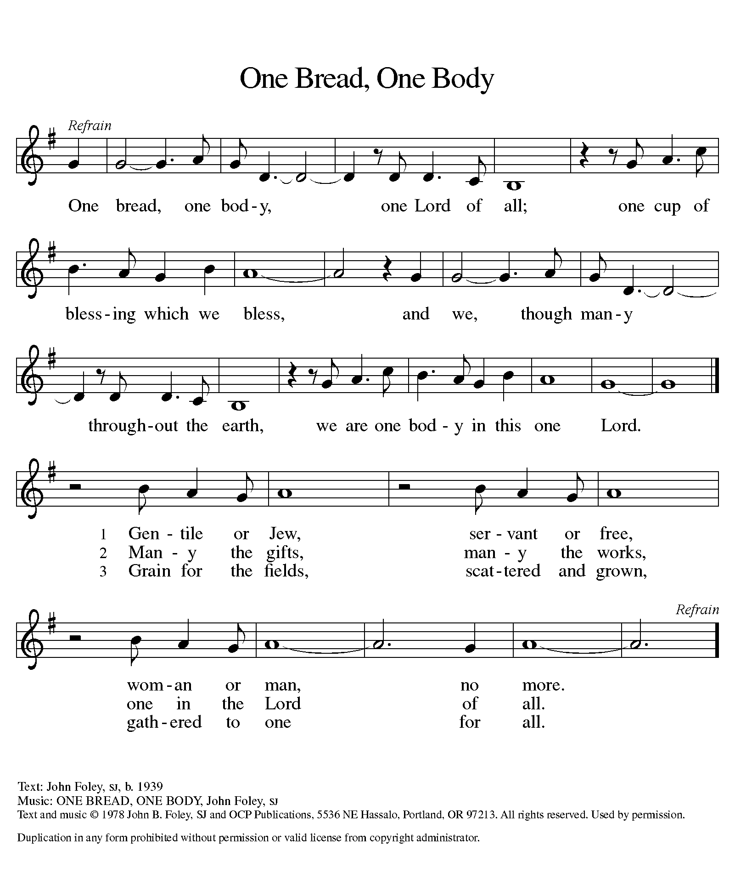

P: Living God,
you gather the wolf and the lamb to feed together
in your peaceable reign,
and you welcome us all at your table.
Reach out to us through this meal,
and show us your wounded and risen body,
that we may be nourished and believe
in Jesus Christ, our Savior and Lord. C: Amen

The mEal

Christ is truly present in the bread and the wine. This makes communion one of the places where God’s touch can be most clearly felt. [Grape juice and gluten-free wafers are available upon request.]

P: God of all creation, all you have made is good,
C: and your love endures forever.
P: You bring forth bread from the earth
C: and fruit from the vine.
P: Nourish us with these gifts,
C: that we might be for the world signs of your gracious presence.
C: Amen

P: In the night in which he was betrayed, our Lord Jesus took bread, and gave thanks; broke it, and gave it to his disciples, saying: Take and eat; this is my body, given for you. Do this for the remembrance of me.
Again, after supper, he took the cup, gave thanks, and gave it for all to drink, saying: This cup is the new covenant in my blood, shed for you and for all people for the forgiveness of sin.

Do this for the remembrance of me. For as often as we eat of this bread and drink from this cup, we proclaim the Lord’s death until he comes.
C: Christ has died. Christ is risen. Christ will come again

LORD’S PRAYER
P: Let us pray the prayer that our Lord first gave us.
C: Our Father, who art in heaven, hallowed be thy name,
thy kingdom come, thy will be done,
on earth as it is in heaven.
Give us this day our daily bread;
and forgive us our trespasses,
as we forgive those who trespass against us;
and lead us not into temptation, but deliver us from evil.
For thine is the kingdom,
and the power, and the glory, forever and ever. C: Amen.
(The assembly is seated)
P: The body and blood of our Lord Jesus Christ strengthen you
and keep you in his grace. C: Amen

P: We give you thanks, generous God,
for in this bread and cup
we have tasted the new heaven and earth
where hunger and thirst are no more.
Send us from this table as witnesses to the resurrection,
that through our lives, all may know life in Jesus’ name. C: Amen

SENDING

BLESSING (Please Stand)
P: God, the Author of life,
Christ, the living Cornerstone,
and the life-giving Spirit of adoption,
☩ bless you now and forever.
C: Amen. [The assembly is seated.]

BRIEF ANNOUNCEMENTS & WEEKLY REFLECTION

(Please Stand)
The Church’s One Foundation ELW #654
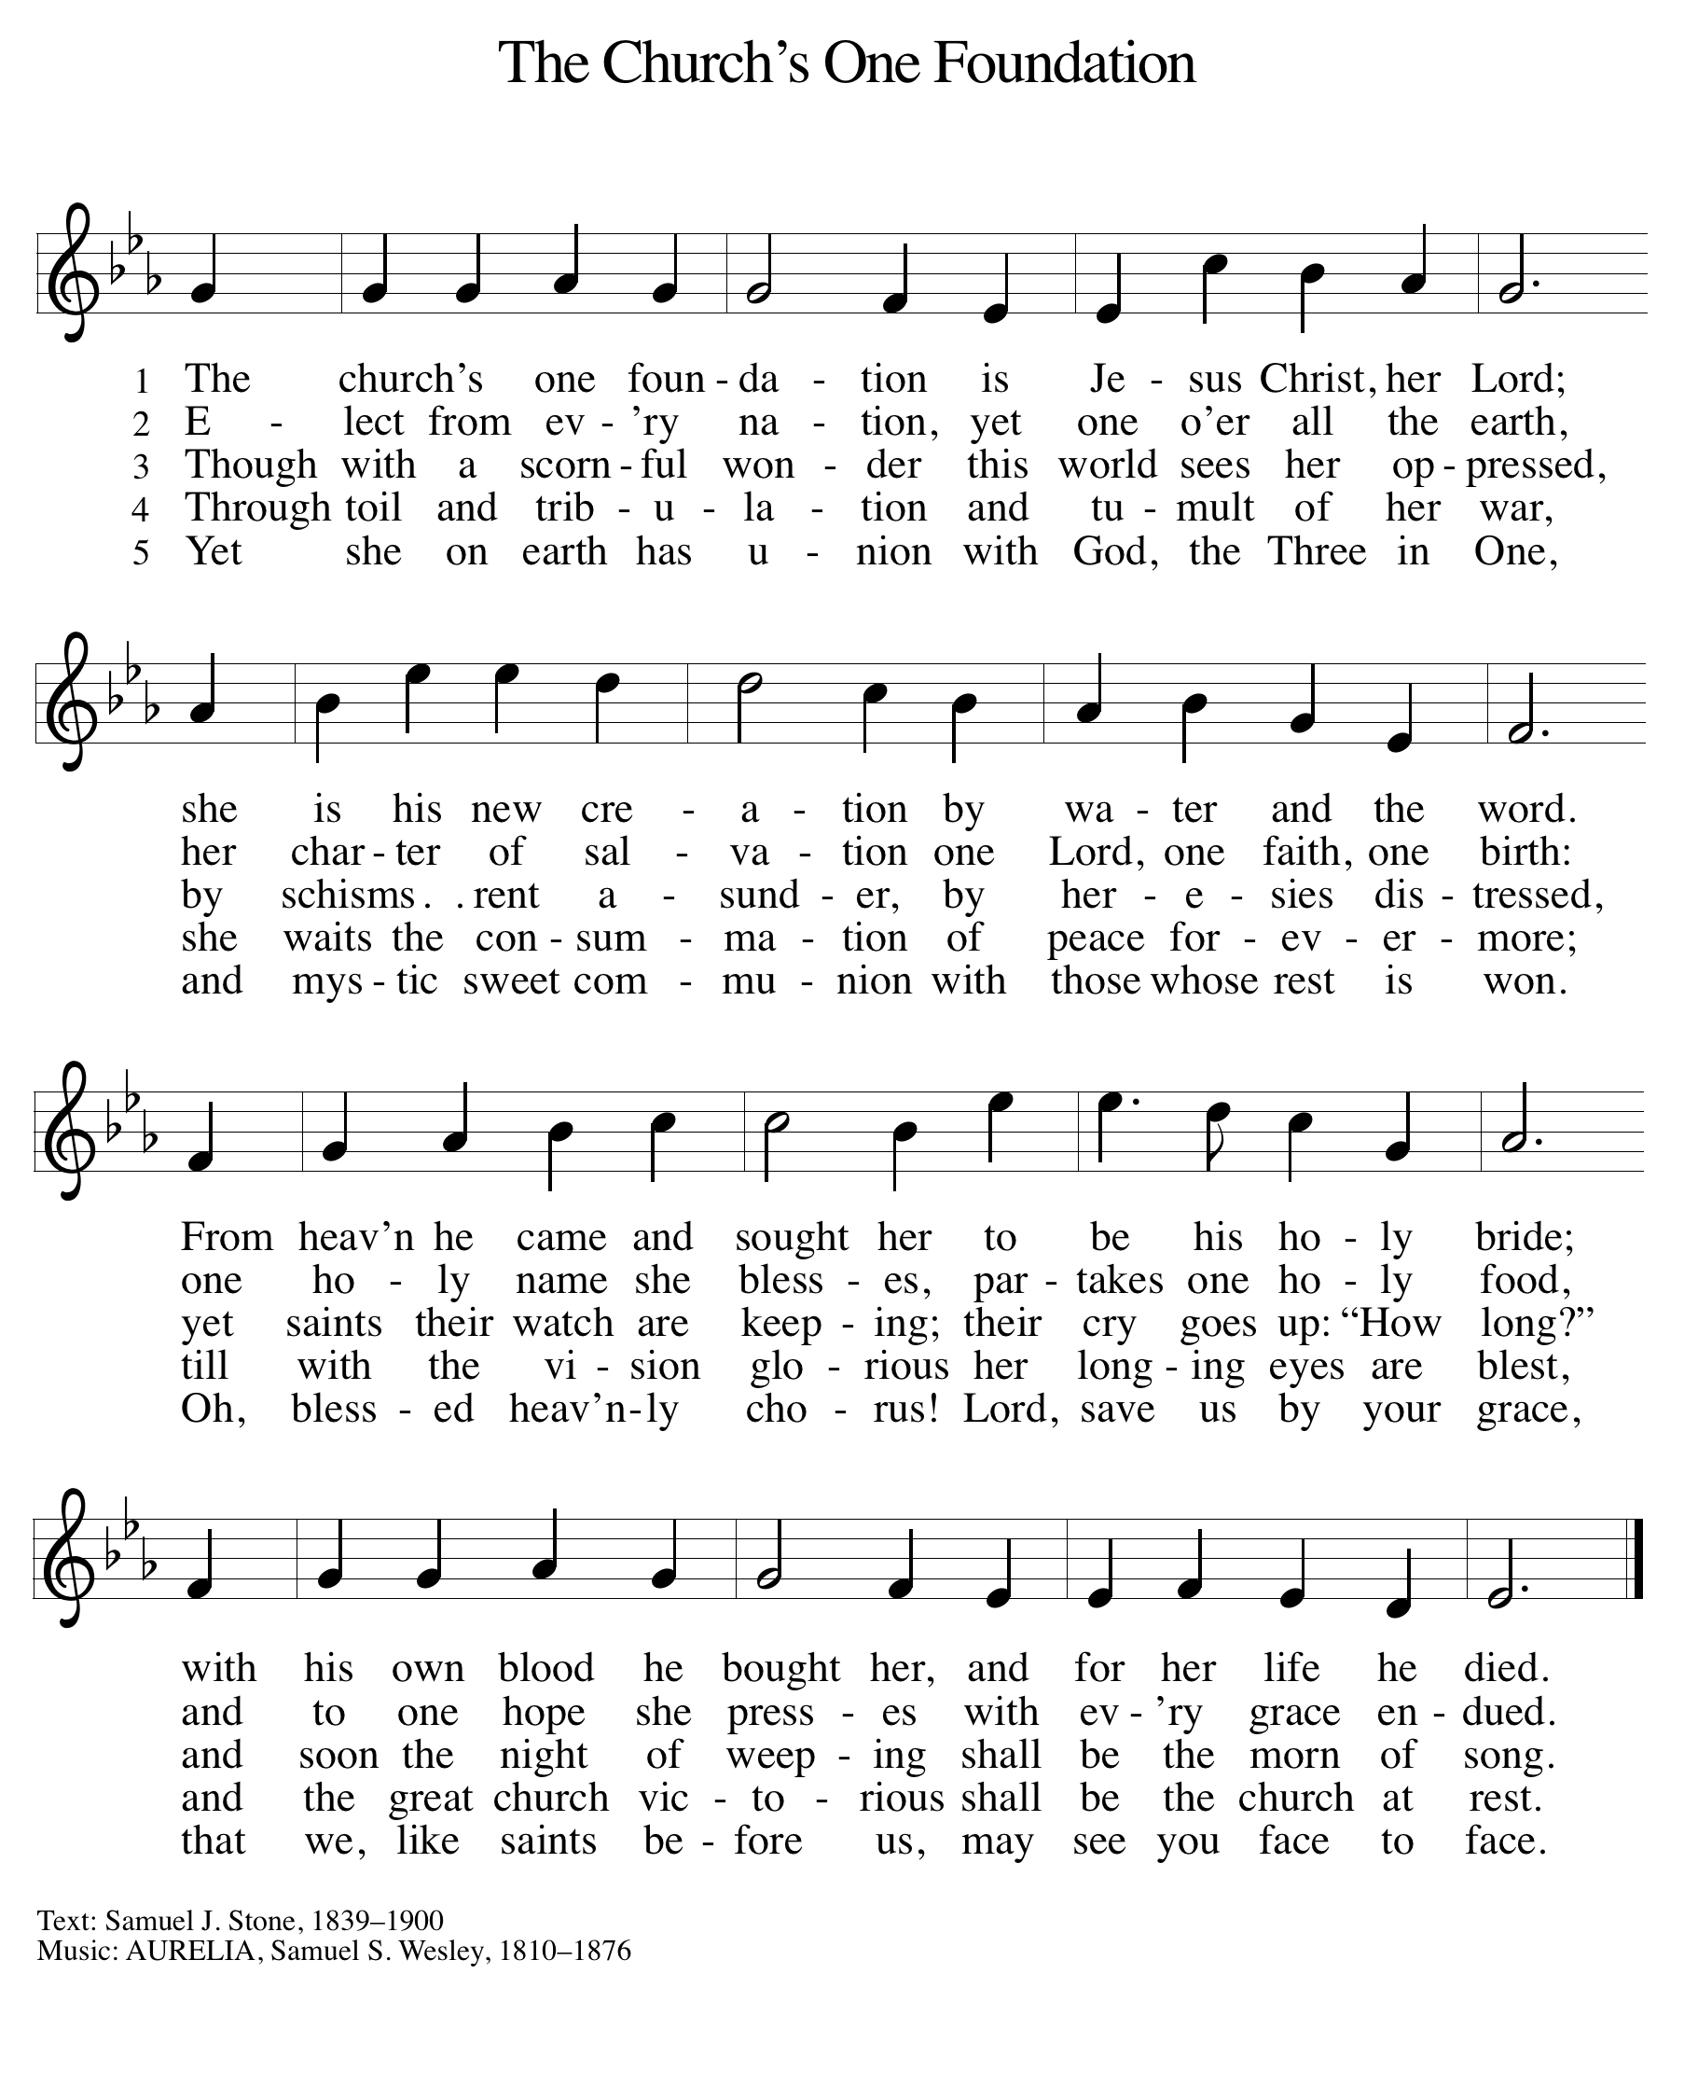

DISMISSAL
P: Alleluia! Christ is risen.
Christ is risen indeed. Alleluia!
Go in peace. Tell what God has done.
C: Thanks be to God.
POSTLUDE

